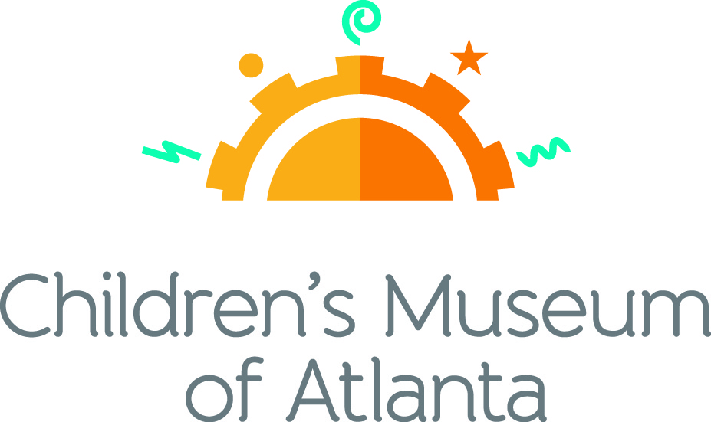

FOR MORE INFORMATION:
Sarah Wynn Benton
BRAVE Public Relations
404.233.3993
sbenton@emailbrave.com

*MEDIA ADVISORY*

Superhero Science Night Launches into Action at Children’s Museum of Atlanta, March 9
Families are invited to explore the heroic powers of knowledge

ATLANTA (Feb. 29, 2024) – Up, up and away! Youngsters are invited to soar to Children’s Museum of Atlanta and discover the magical powers behind learning at Superhero Science Night on Saturday, March 9 from 5:30 – 7:30 p.m. Kids and parents are encouraged to embrace the opportunity to don their favorite superhero attire and embark on a mission to save the world through the applications of science, technology, engineering and mathematics. The event-filled evening promises exciting activities, including constructing a Batmobile, triggering Volcanic Eruptions, unraveling the mysteries of the Disappearing Face and much more.

Attendees can also look forward to hearing how special guest, Decatur Makers Space, designs and creates superhero cosplay props. Visitors can see their incredible props and learn more about 3D printing, LEDs and circuits.

WHAT: Superhero Science Night at Children’s Museum of Atlanta
Families are invited to blast off into the wonderful world of science

WHEN: Saturday, March 9
5:30 – 7:30 p.m.

WHERE: Children’s Museum of Atlanta
275 Centennial Olympic Park Drive, NW
Atlanta, GA 30313

HOW: Tickets are $10 for members / $25 for non-members and must be purchased in advance. Tickets will not be sold at the door. For tickets, visit bit.ly/superherosciencenight2024 or call 404-420-5910.

For more information or to support Children's Museum of Atlanta, visit childrensmuseumatlanta.org
###

